**Open Ended Lab**

**LAB # 13**



**Fall 2024**

**CSE-310L Control Systems Lab**

Submitted by: **Ali Asghar**

Registration No.: **21PWCSE2059**

Class Section: **C**

“On my honor, as student of University of Engineering and Technology, I have neither given nor received unauthorized assistance on this academic work.”

Submitted to:

**Dr. Muniba Ashfaq**

Date:

**10th January 2024**

**Department of Computer Systems Engineering**

**University of Engineering and Technology, Peshawar**

**Task:**

Design negative feedback system both in MATLAB & Simulink and control the step response of given system. Performance requirement of the closed loop system is that the steady state error is zero and overshoot less than 30%.

**Solution:**

Given System is:

$$G(s)=\frac{1}{s^{2}+3s+1}$$

**Code:**

**Output:**

**

**Make a PID Controller and connect it in series with the given system.**

**Code:**

**Output:**

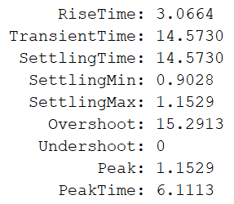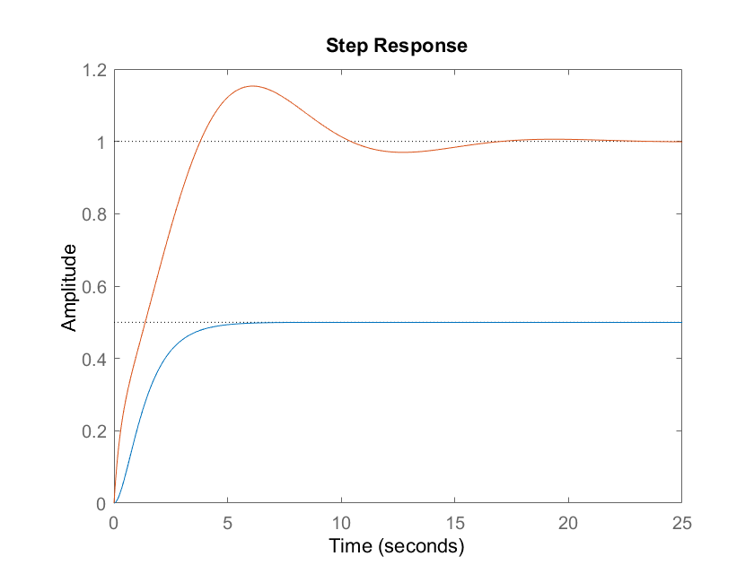

|  |  |  |  |  |  |
| --- | --- | --- | --- | --- | --- |
| Kp | Ki | Kd | Rise time | Overshoot | Settling time |
| 1 | 1 | 1 | 3.0664 | 15.2913 | 14.5730 |
| 2 | 1 | 1 | 2.6355 | 4.5423 | 8.6536 |
| 3 | 1 | 1 | 2.1970 | 0 | 3.9121 |
| 4 | 1 | 1 | 1.7348 | 0 | 6.6004 |
| 5 | 1 | 1 | 1.3212 | 0 | 8.5893 |
| 6 | 1 | 1 | 1.0402 | 0 | 9.9991 |
| 7 | 1 | 1 | 0.8623 | 0 | 11.1156 |
| 8 | 1 | 1 | 0.7435 | 0 | 12.0324 |
| 9 | 1 | 1 | 0.6588 | 1.1576 | 12.7951 |
| 10 | 1 | 1 | 0.5949 | 3.1044 | 13.4306 |

**Output:**

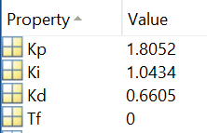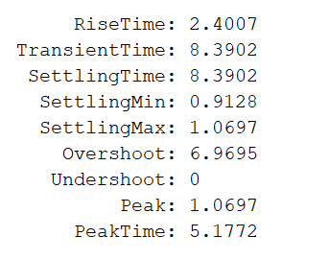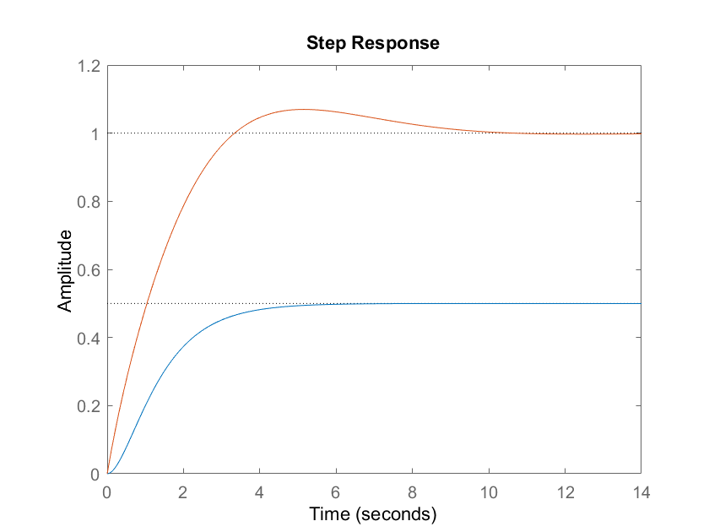

**Simulink:**

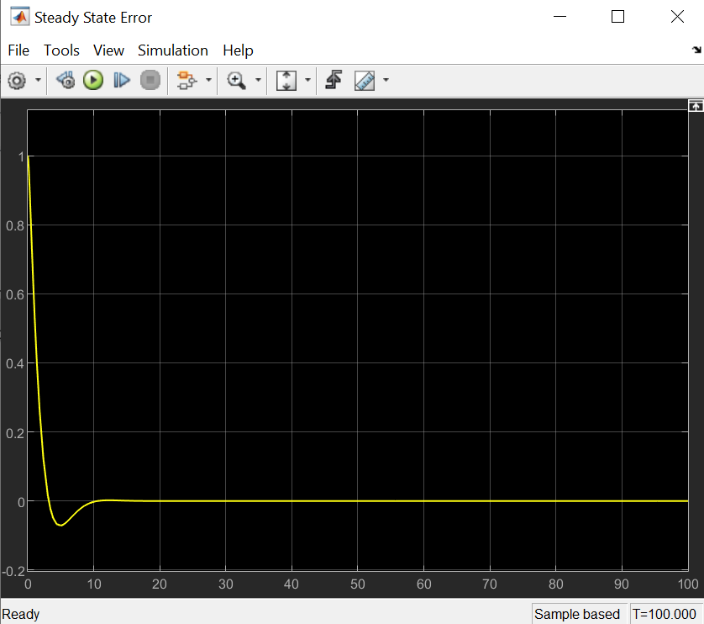

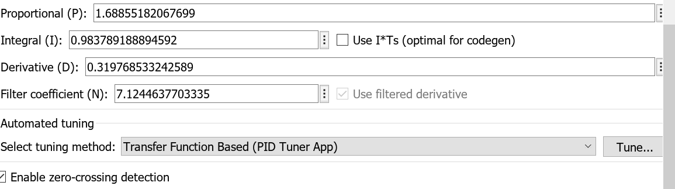

**Conclusion:**

A PID Controller was designed successfully for reducing the steady state error of the given system.